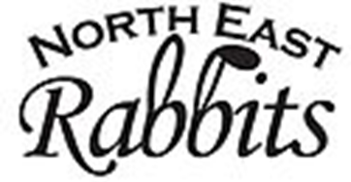
27th ANNUAL BENEFIT GOLF TOURNAMENT
SPONSORSHIP FORM

The Northeast Rabbits are pleased to announce their 27th Annual Benefit Golf Tournament to be held at the Oakmont Green Golf Course on Friday, July 12th, 2019.

As you may know, we need sponsors such as yourself to help make this benefit a success. All proceeds go toward the Children’s Christmas Fund. Sponsorship Opportunities are as follows:

_ EXECUTIVE SPONSOR: $1,000 - Includes a sign prominently displayed on a tee with your name or company name AND a complimentary foursome.
BEVERAGE SPONSOR: $250 – Includes a sign prominently displayed on the beverage cart with your name or company name.
TEE SPONSORS: Includes a sign to be prominently displayed on a tee with your name or company name with sponsorship level.
GOLD SPONSOR: $100 ______________
SILVER SPONSOR: $75 ______________
BRONZE SPONSOR: $50 ______________
CART SPONSOR: $35 – Includes a sign to be prominently displayed on a golf cart with your name or company name.
PROGRAM SPONSOR: $25 – Your name, company name or business card will be printed in our tournament program.

_______ OTHER - Any and All Donations are Appreciated: $_________

SPONSOR’S NAME: __________________________________
ADDRESS: _________________________________________
ADDRESS: _________________________________________

Please select the sponsorship of your choice and submit your check to:
The Northeast Rabbits
c/o Rick Waltrup
4637 Water Tank Road
Manchester, MD 21102

For more information call 410-294-6418, email northeastrabbits@gmail.com or visit our website
www.northeastrabbits.org

